Routing Params ->

Created two more route path ‘mock-tests’ & ‘mock-tests-details’

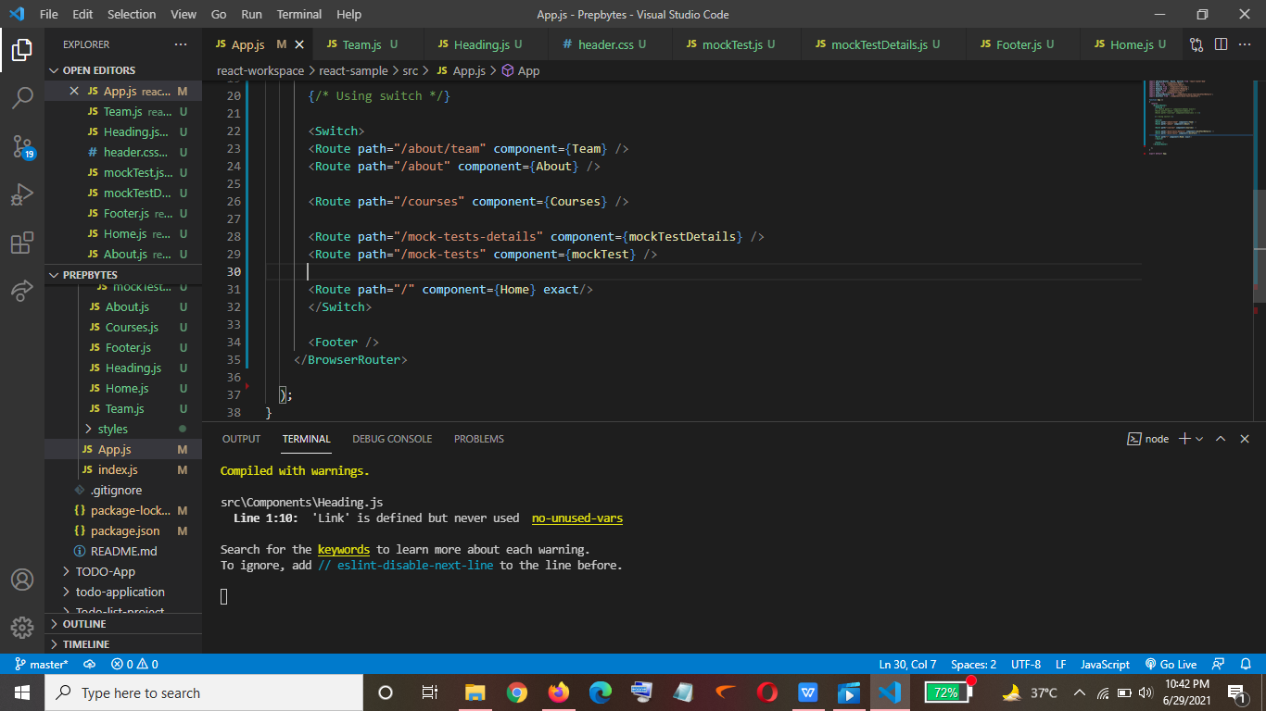

Output->

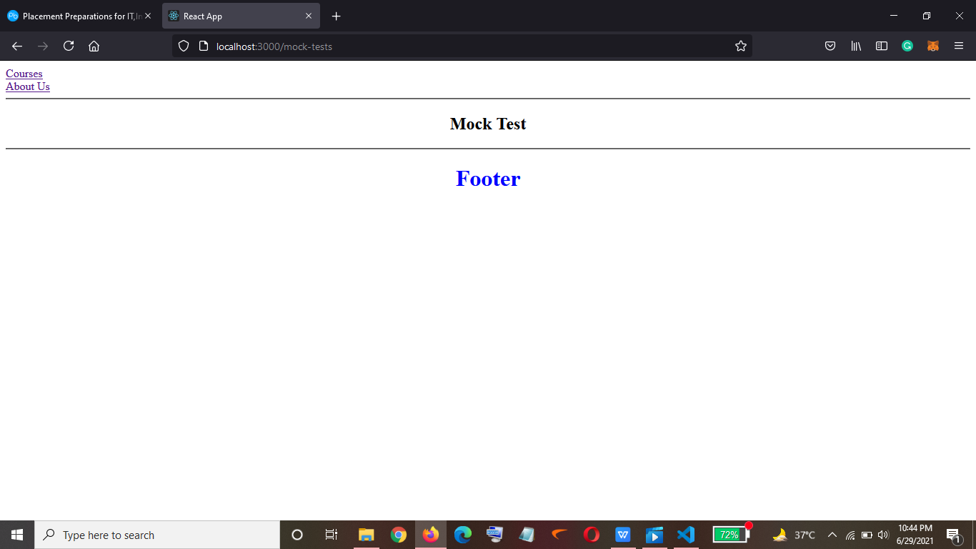

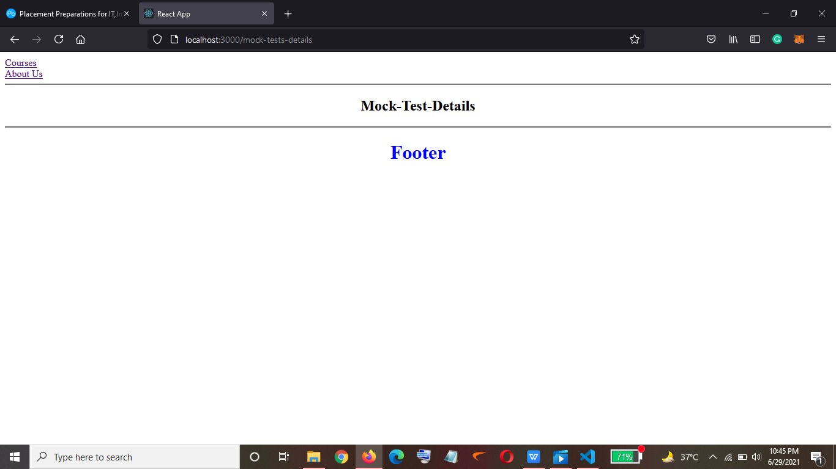

Mocktest.js

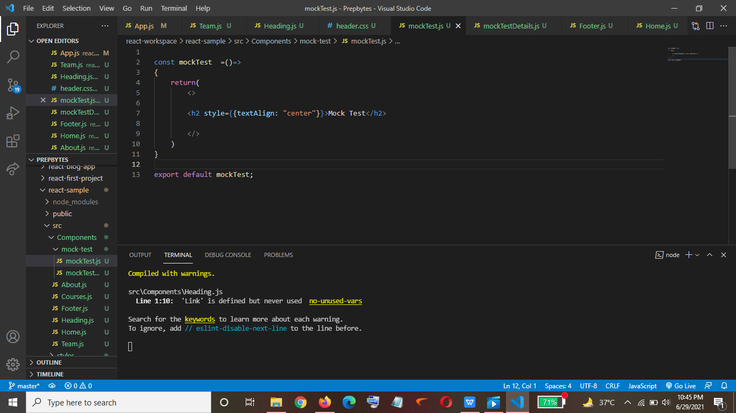

MockTestDetails.js

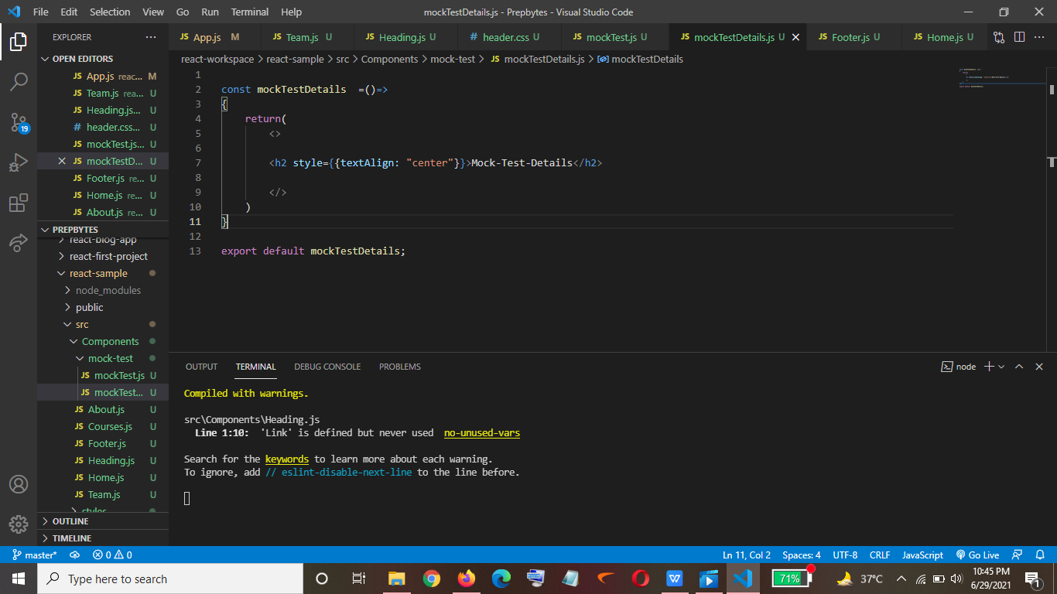

When I use parameters in the route where we write path ->

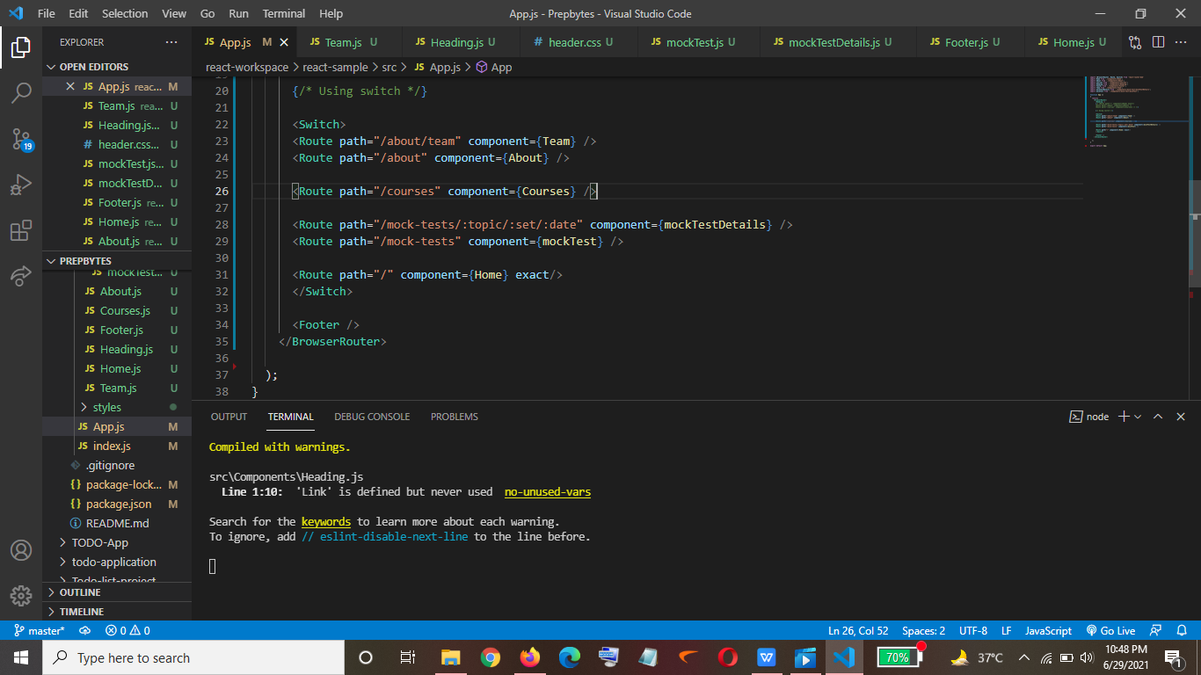

So to access that I will have to give the value of the three parameters I have passed in the url->

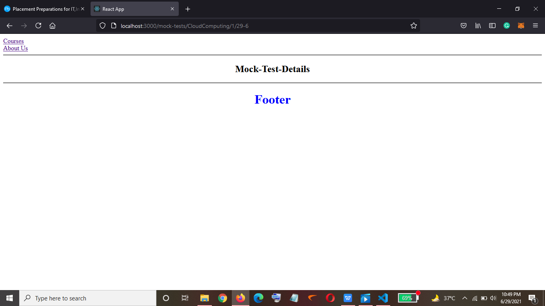

Accessing the value of the parameters passed in the url using props

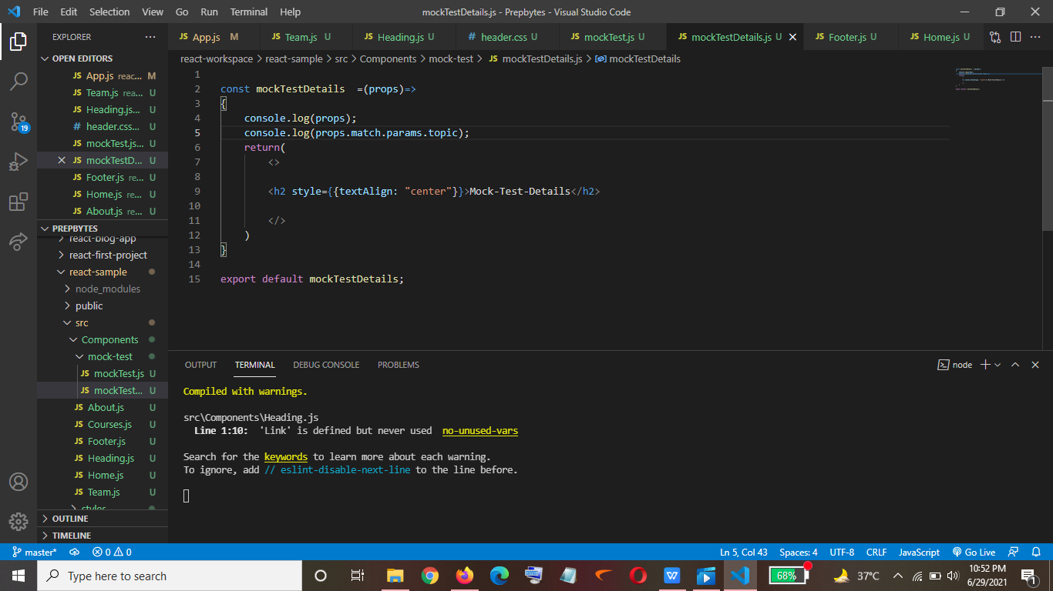

Output->

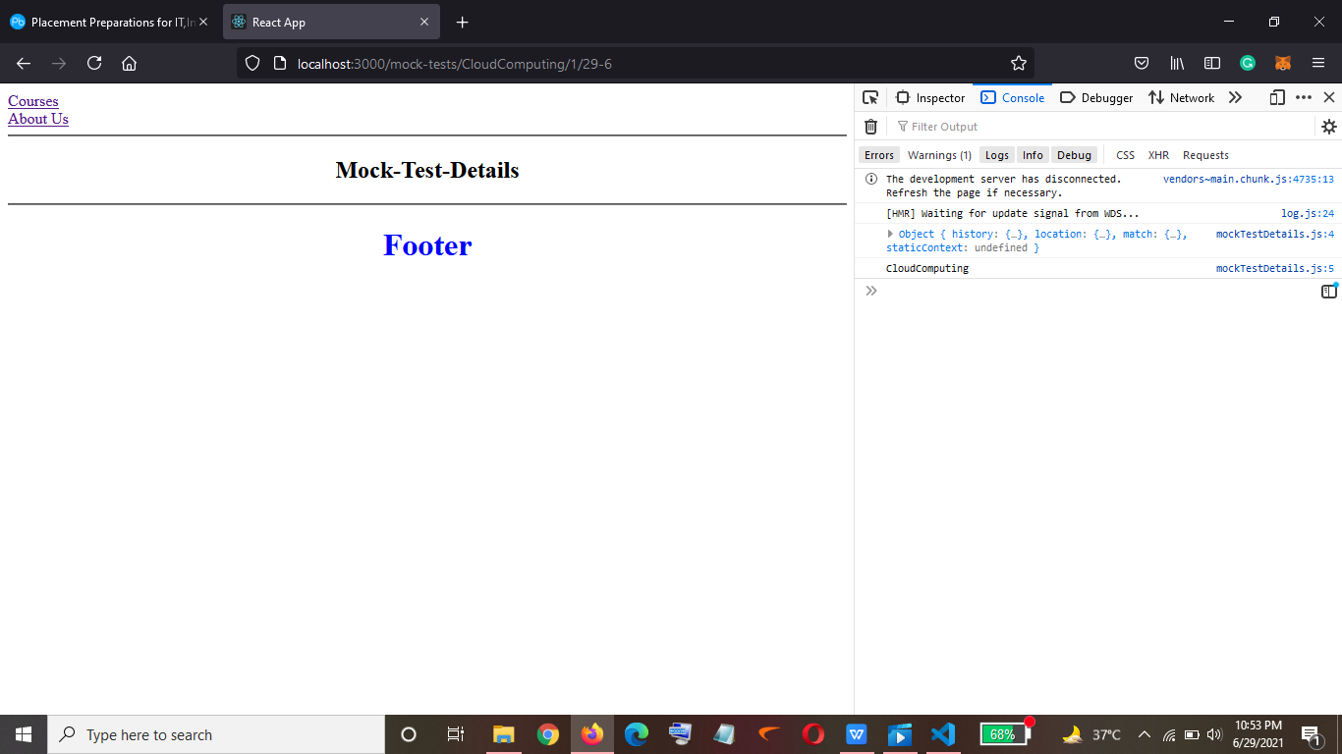

Now If we want the value of parameters passed in the url to be displayed on that web page ->

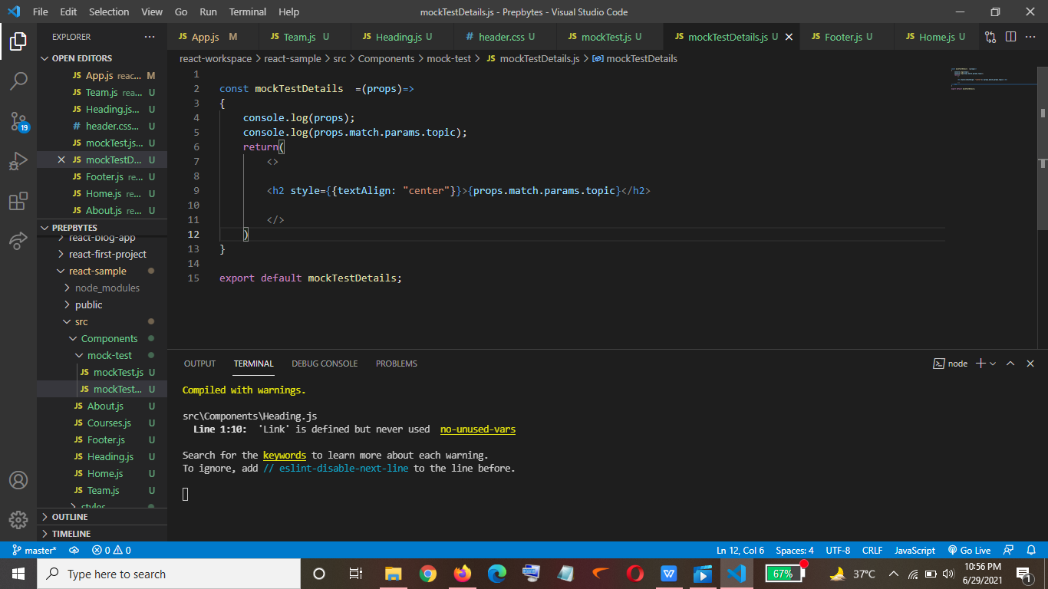

Output->

Now as I passed value of topic parameter as ‘Cloud Computing’ so the same will be displayed on the screen. ->

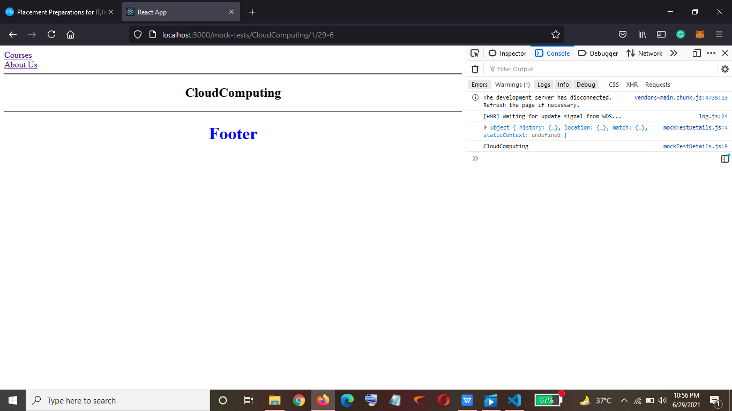

Now when I pass Operating Systems then it will be displayed->

